Name: Pranali Sonawane
Subject: MCSA
Date: 15-01-2026
Lab 25: FSRM

Server 1:
- Install File Server Resources Manager(FSRM)
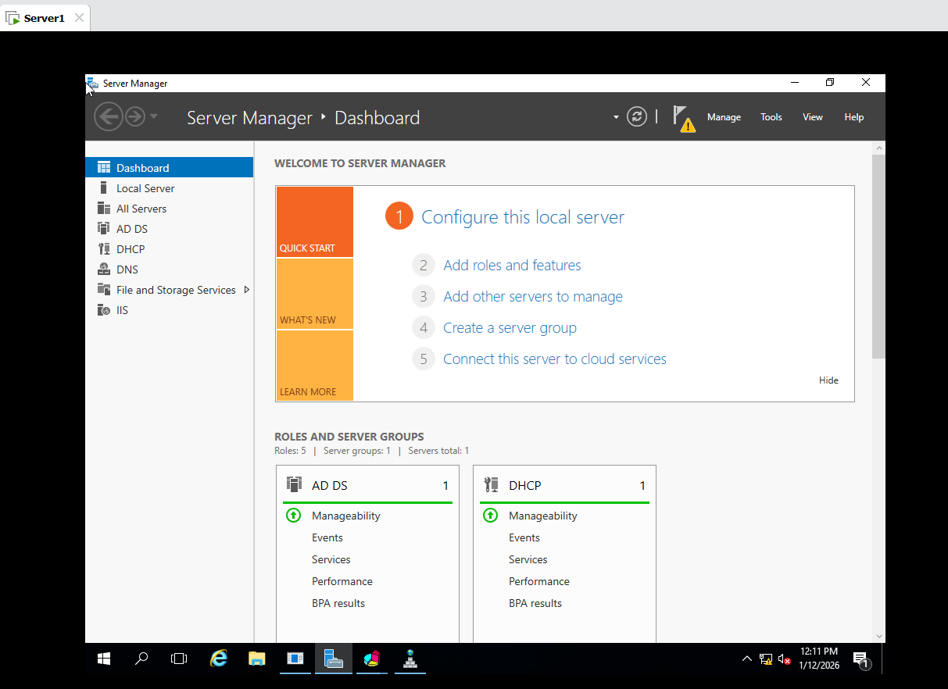
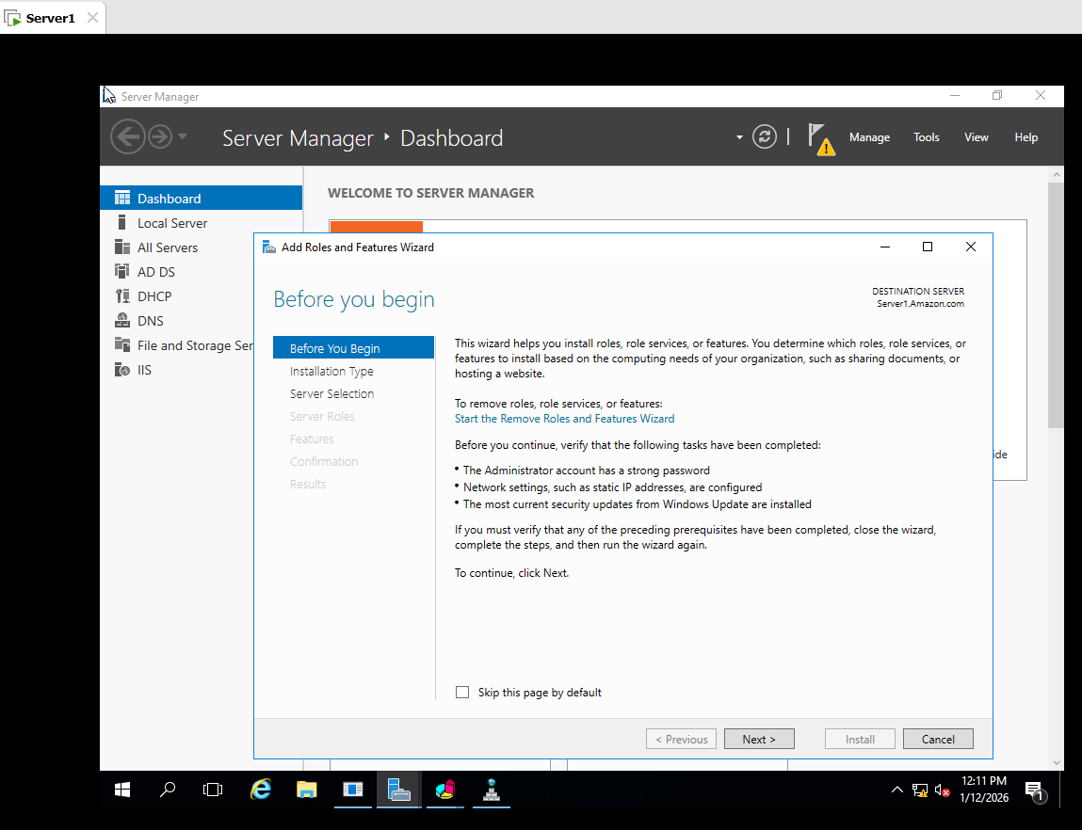

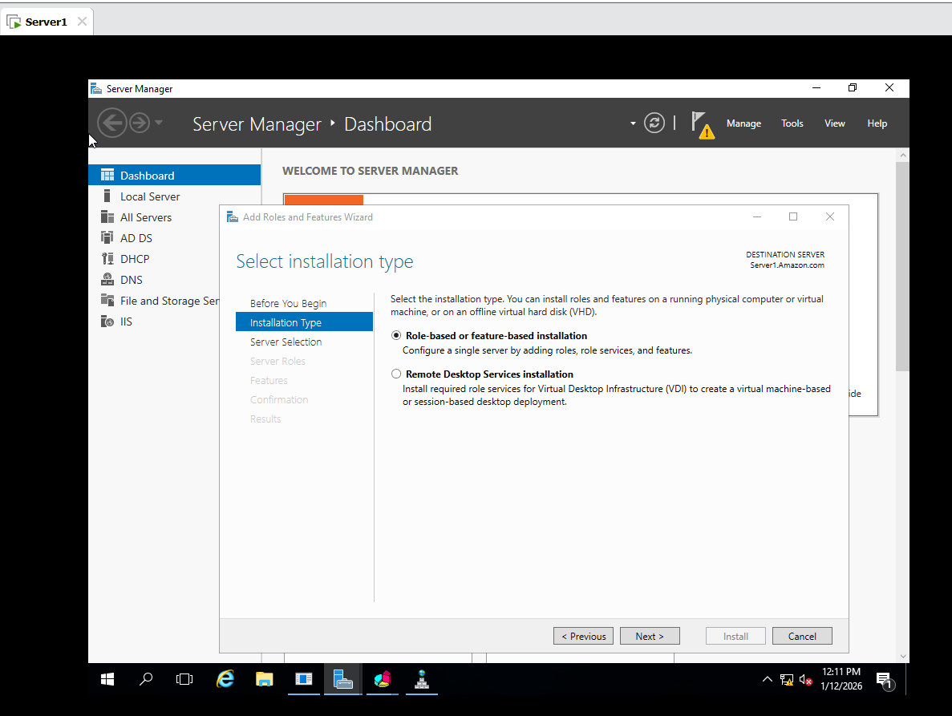
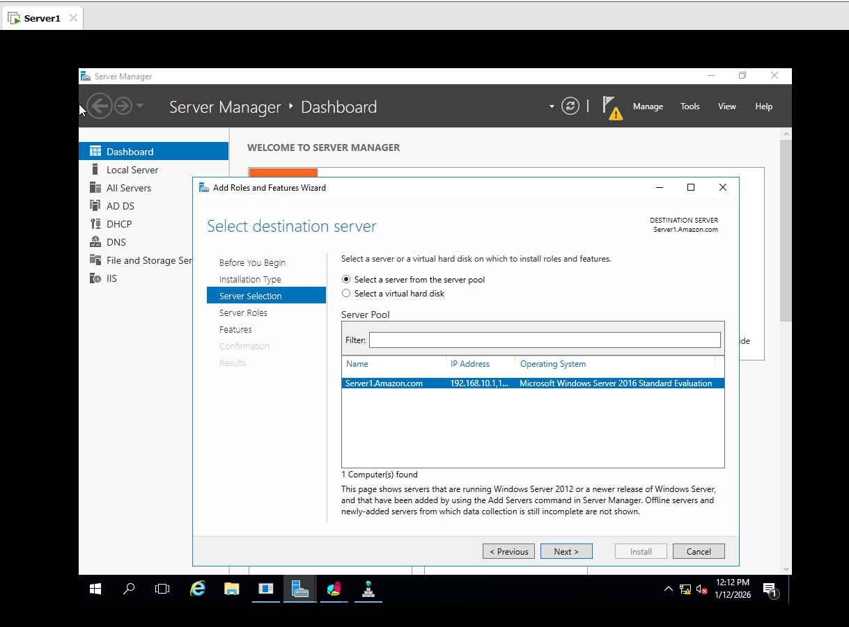
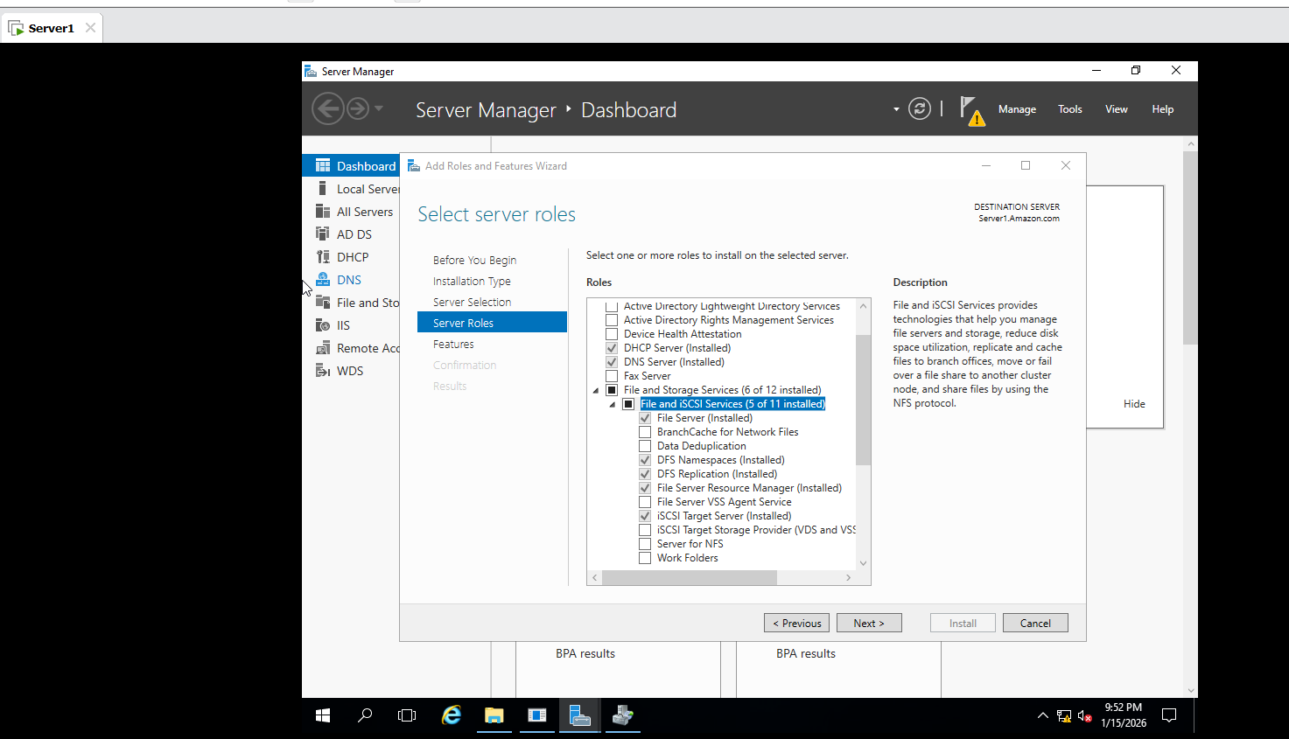

Quota Management :
- C Drive : Create a new Folder Test
- Open FSRM : Server Manager Tools File Server Resource Manager Quota Management
- Create 50 MB Hard Quota :
- In FSRM Quota Management
- Click Quotas
- Right-Click: Create Quota
- Configure Quota:
Quota Path: C:\Test
- Select :
Define Custom Quota Properties
- Quota Type:
Select Hard Quota
- Set Limit:
- Quota Limit: 50 MB
- Click Create
- OK
- Test the Quota :
- Take any File larger than 50 MB
- Try to Copy or Past in into :
C:\Test
- Show Error

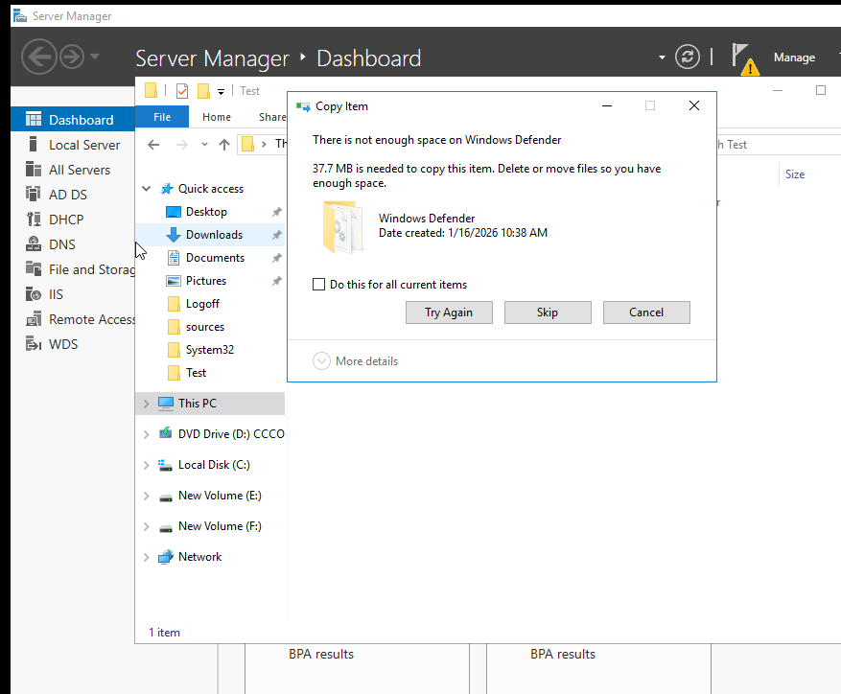

- File Screening Management :
- C Drive : Create a new Folder Hello
- Open FSRM : Server Manager Tools File Server Resource Manager File Screening Management
- Click File Group
- Confirm Images Files Group Exists : First Remove *.bmp then repeat add *.bmp
- Go to File Screen Templates
- Right-click Create File Screen Template
- Configure:
- Template Name:
Block_Image_Files1
9.Screening Type: Active Screening
10. File Group : Click Add
Select: Image Files
- Click Ok
- Apply Files Screening to folder Hello
- Configure:
File Screen Path: C:\Hello
Select: Device Properties from a file screen template
- Choose Template:
Block_Image_Files
Click Create
- This PC C Drive Folder Hello save *.bmp then show Error

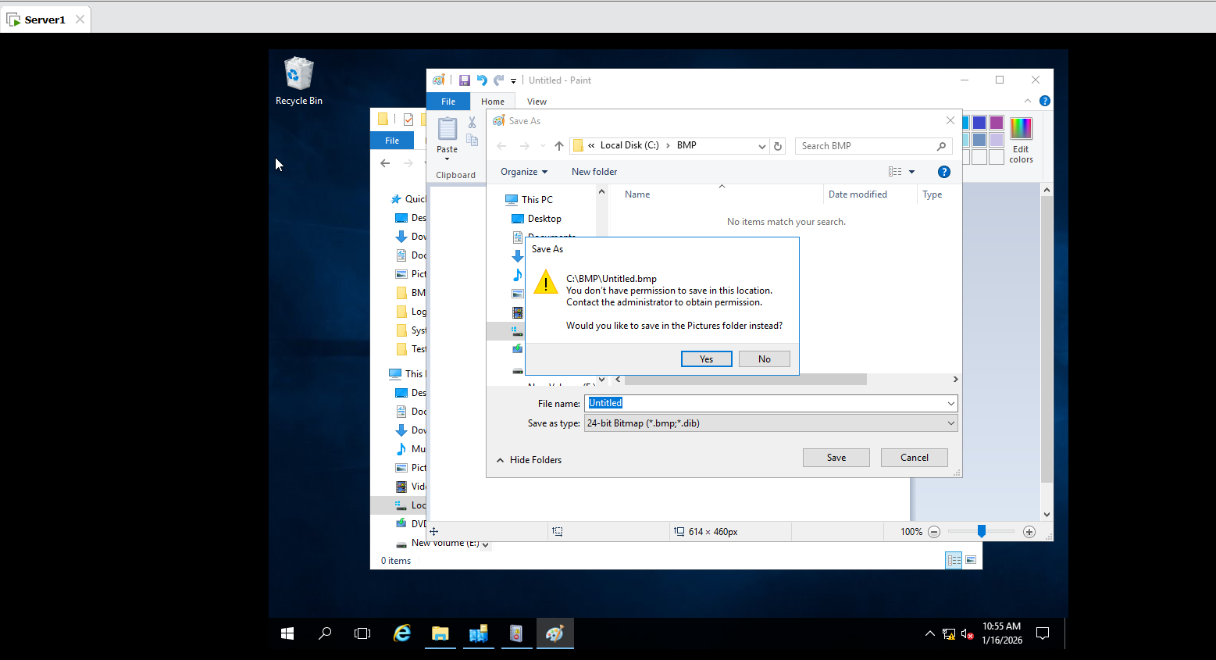
Server 1:
- Tools Event Viewer : 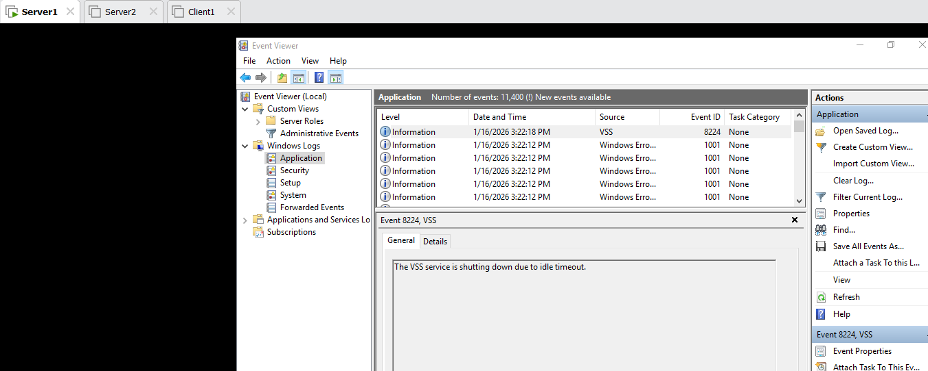

- Tools Performance Monitor:
1.Performance Monitor is a Windows tool used to monitor, record and analyze System performance using performance Counters.
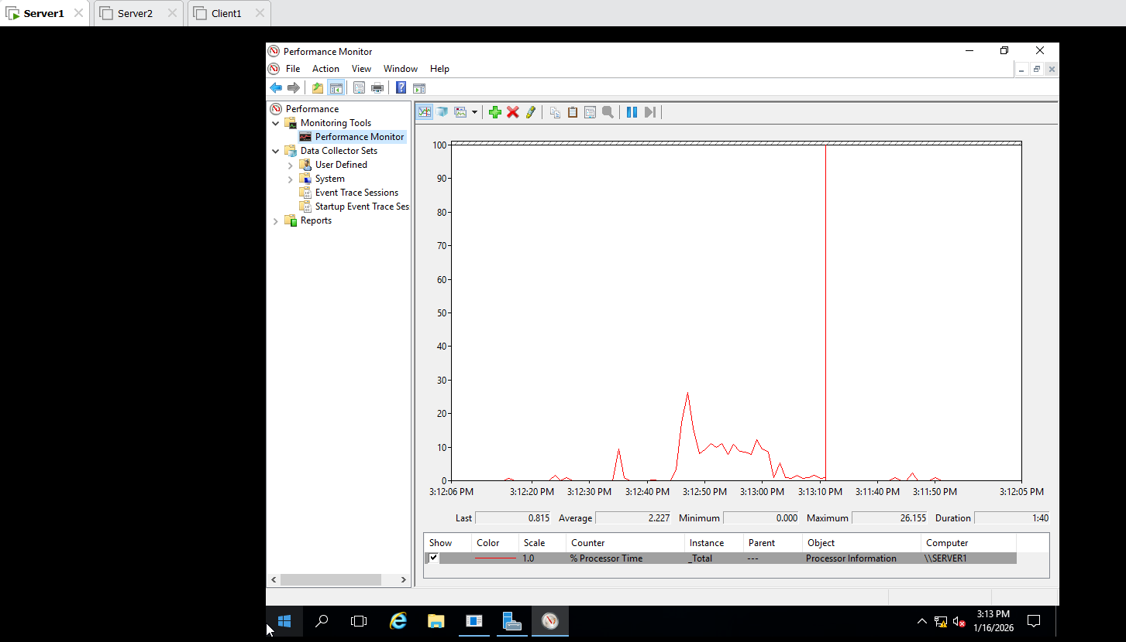

Task Manager:
Windows OS : Check on Task Manager

